**PROJECT DESIGN PHASE 2**

**DATA FLOW DIAGRAM & USER STORIES**

|  |  |
| --- | --- |
| **Date** | **14 October 2022** |
| **Team ID** | **PNT2022TMID08369** |
| **Project Name** | **IoT based smart crop protection system for agriculture** |
| **Maximum Marks** | **4 Marks** |

**DATA FLOW DIAGRAM:**

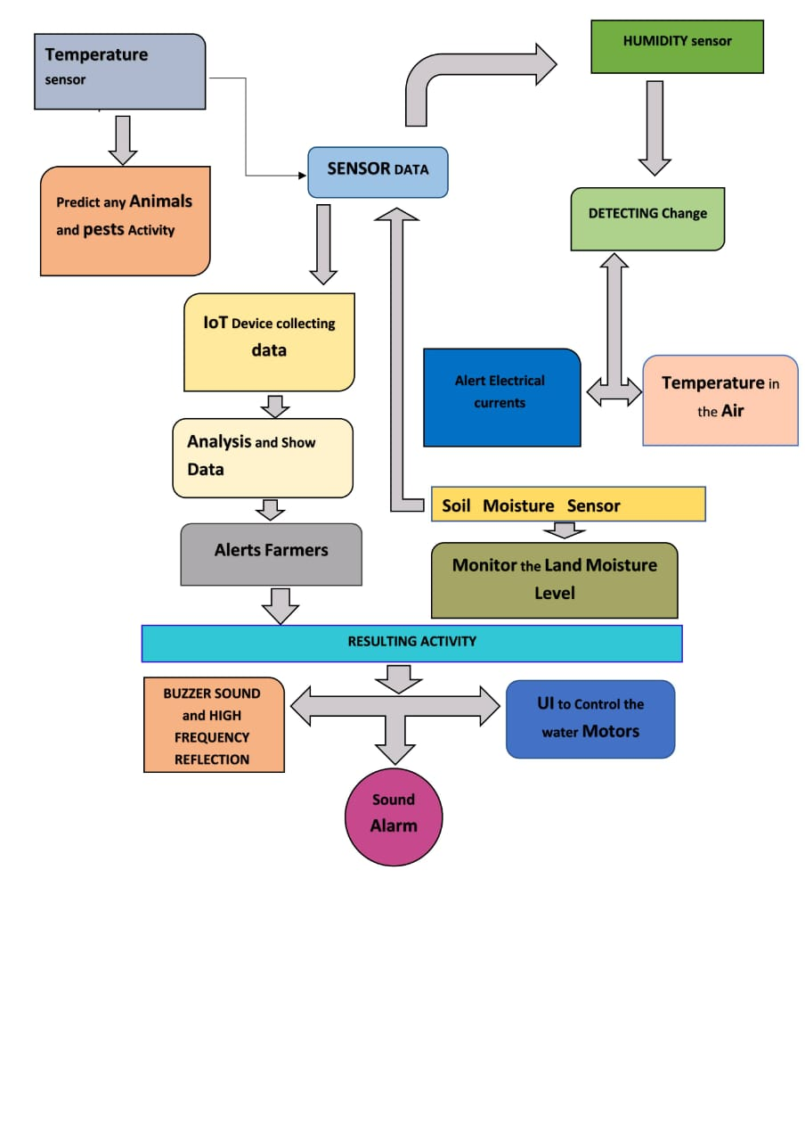

|  |  |  |  |  |  |  |
| --- | --- | --- | --- | --- | --- | --- |
| **User Type** | **Functional requirement (Epic)** | **User**  **Story**  **number** | **User Story/Task** | **Acceptance criteria** | **Priority** | **Release** |
| Customer (Mobile  user) | Registration | USN-1 | User can enter into the web application | I can access my account /dashboard | High | Sprint 1 |
|  |  | USN-2 | User can register their credentials like email id and password | I can receive confirmation email & click confirm | High | Sprint 1 |
|  | Login | USN-3 | User can log into the application by entering email & password | I can login to my account | High | Sprint 1 |
|  | Dashboard | USN-4 | User can view the temperature | I can view the data given by the device | High | Sprint 2 |
|  |  | USN-5 | User can view the level of sensor monitoring value | I can view the data given by the device | High | Sprint 2 |
| Customer (Web user) | Usage | USN-1 | User can view the webpage and get the information | I can view the data given by the device | High | Sprint 3 |
| Customer | Working | USN-1 | User act according to the alert given by the device | I can get the data work according to it | High | Sprint 3 |
|  |  | USN-2 | User turns ON the water motors/Buzzer/Sound Alarm when occur the disturbance on field. | I can get the data work according to it |  | Sprint 4 |
| Customer care Executive | Action | USN-1 | User solve the problem when some faces any usage issues | I can solve the issues when someone fails to understanding the procedure | High | Sprint 4 |
| Administration | Administration | USN-1 | User store every information | I can store the gained information | High | Sprint 4 |